Session 3: Advanced Queries and Table Joins

1. Objective
To perform data analysis using aggregate functions and to combine data from multiple tables using various JOIN operations for the Project-Hub database.

2. Implementation Queries
Step 1: Basic Selection and Aggregation
SELECT * FROM Student;
SELECT * FROM Course;
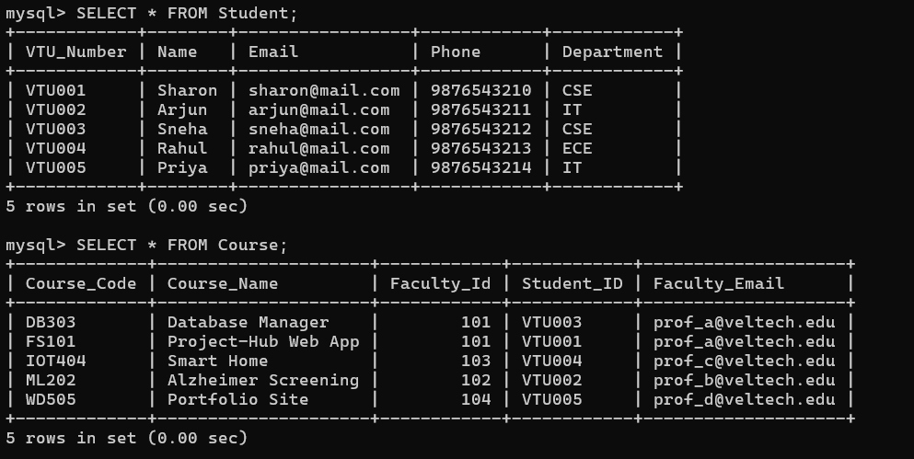
SELECT COUNT(*) AS Total_Students FROM Student;
SELECT COUNT(DISTINCT Department) AS Department_Count FROM Student;
SELECT MAX(Faculty_Id) AS Highest_Faculty_ID FROM Course;
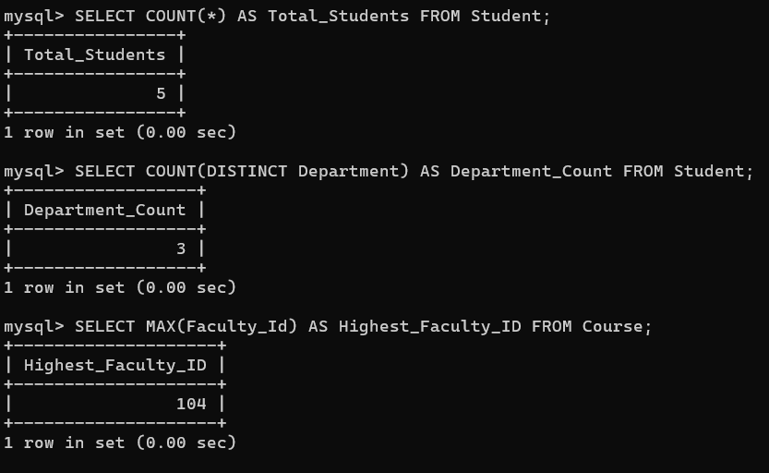
Step 2: Sorting Data
Organizing students by their VTU ID.
SELECT * FROM Student ORDER BY VTU_Number ASC;
SELECT * FROM Student ORDER BY VTU_Number DESC;
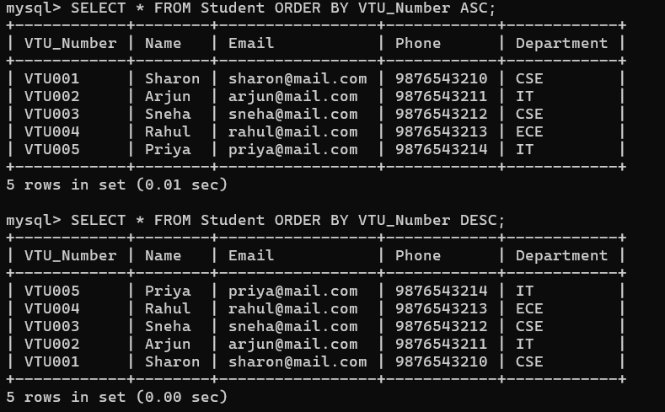

Step 3: Filtering by Department
Finding specific groups of students.
SELECT * FROM Student WHERE Department = 'CSE';
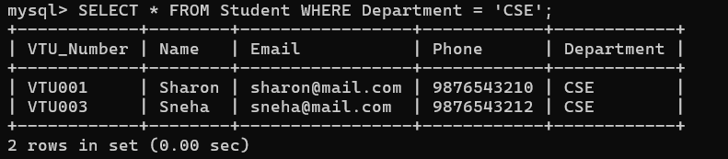

Step 4: Mapping Students to Projects (Joins)
Inner Join (Shows only students who have a project assigned):
SELECT s.VTU_Number, s.Name AS Student_Name, c.Course_Name, c.Faculty_Email
FROM Student s
INNER JOIN Course c ON s.VTU_Number = c.Student_ID;
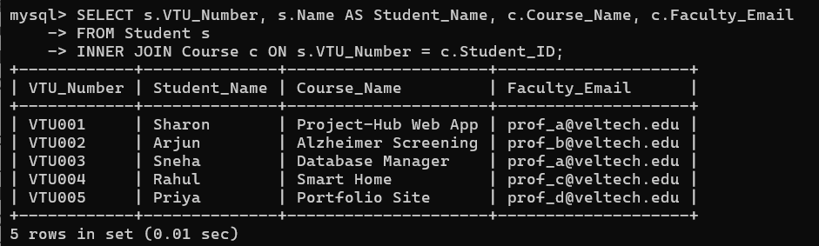
Left Join (Shows ALL students, even those who haven't uploaded a project yet):
SQL
SELECT s.VTU_Number, s.Name, c.Course_Name
FROM Student s
LEFT JOIN Course c ON s.VTU_Number = c.Student_ID;
